# CS 255 Business Requirements Document Template

Complete this template by replacing the bracketed text with the relevant information.

This template lays out all the different sections that you need to complete for Project One. Each section has guiding questions to prompt your thinking. These questions are meant to guide your initial responses to each area. You are encouraged to go beyond these questions using what you have learned in your readings. You will need to continually reference the interview transcript as you work to make sure that you are addressing your client’s needs. There is no required length for the final document. Instead, the goal is to complete each section based on your client’s needs.

**Tip:** You should respond in a bulleted list for each section. This will make your thoughts easier to reference when you move into the design phase for Project Two. One starter bullet has been provided for you in each section, but you will need to add more.

## System Components and Design

### Purpose

*What is the purpose of this project? Who is the client and what do they want their system to be able to do?*

* The client’s name is driver pass and they want to provide access for students that are online to the ability the provide training and online classes for the driver’s tests.

### System Background

*What does DriverPass want the system to do? What is the problem they want to fix? What are the different components needed for this system?* [*Reference from snhu*](https://learn.snhu.edu/content/enforced/1196060-CS-255-T2791-OL-TRAD-UG.22EW2/course_documents/CS%20255%20DriverPass%20Interview%20Transcript.pdf?_&d2lSessionVal=98fQUlkkf61ZnT6HG1ROPbsxy&ou=1196060)

* The owner of the Driverpass has noticed several people failing the exams and needs better training for testers.
* The owner has an interest in proving 3 packages:

1. Package One: Six hours in a car with a trainer

2. Package Two: Eight hours in a car with a trainer and an in-person lesson where we explain the DMV rules and policies

3. Twelve hours in a car with a trainer, an in-person lesson where we explain the DMV rules and policies—plus access to our online class with all the content and material. The online class also includes practice tests

### Objectives and Goals

*What should this system be able to do when it is completed? What measurable tasks need to be included in the system design to achieve this?*

* Project is not complete until it meets the satisfaction requirements set by Driverpass
* System needs to be run over web, preferably the cloud
* Web needs to be connected to DMV, incase updates regarding rules, policies, and questions

## Requirements

### Nonfunctional Requirements

*In this section, you will detail the different nonfunctional requirements for the DriverPass system. You will need to think about the different things that the system needs to function properly.*

#### Performance Requirements

*What environments (web-based, application, etc.) does this system need to run in? How fast should the system run? How often should the system be updated?*

* The system needs to be run over the web, based off the cloud so files can still be downloaded if offline.

#### Platform Constraints

*What platforms (Windows, Unix, etc.) should the system run on? Does the back end require any tools, such as a database, to support this application?*

* The platform should be ran over apple since it is easier to understand and a flat rate.
* A SQL database will be needed for all user information.

#### Accuracy and Precision

*How will you distinguish between different users?* *Is the input case-sensitive? When should the system inform the admin of a problem?*

* There are different user types that would be set by the administrator or other level provided access given by admin
* Base User normal user using tests
* DMV rep the user who can update information such as test, policy and questions
* IT department access to everything besides admin documents that can edit high level areas of the site, has the ability to edit user data
* Admin who has access to provide and remove roles

#### Adaptability

*Can you make changes to the user (add/remove/modify) without changing code? How will the system adapt to platform updates? What type of access does the IT admin need?*

* IT Admin needs a lot of privileges since they are the legs of the systems
* Edit client and system settings
* Edit corrupt files as needed with admin approval
* Delete, remove, add, rename users.
* See system log of users of all levels exception admin

#### Security

*What is required for the user to log in? How can you secure the connection or the data exchange between the client and the server? What should happen to the account if there is a “brute force” hacking attempt? What happens if the user forgets their password?*

* 2auth will be needed with all accounts
* ID.ME will be even extra for user verification
* Valid identification to create an account ran through DMV to make sure identify is correct to prevent Bruteforce attempts

### Functional Requirements

*Using the information from the scenario, think about the different functions the system needs to provide. Each of your bullets should start with “The system shall . . .” For example, one functional requirement might be, “The system shall validate user credentials when logging in.”*

* The system shall authenticate 2auth users
* The system shall authenticate id.me verification
* The system shall provide accurate and precise verification through DMV database

### User Interface

*What are the needs of the interface? Who are the different users for this interface? What will each user need to be able to do through the interface? How will the user interact with the interface (mobile, browser, etc.)?*

* The interface needs to be user friendly regardless the level of the user.
* Admin needs to be able to see everything as friendly as possible
* IT needs to still be able to access logs and user data

### Assumptions

*What things were not specifically addressed in your design above? What assumptions are you making in your design about the users or the technology they have?*

* There will be a free document for users whose client does not state
* There is amount set in stone set by the client, budget-friendly unless otherwise stated

### Limitations

*Any system you build will naturally have limitations. What limitations do you see in your system design? What limitations do you have as far as resources, time, budget, or technology?*

* 3 ½ months for completion

### Gantt Chart

*Please include a screenshot of the GANTT chart that you created with Lucidchart. Be sure to check that it meets the plan described by the characters in the interview.*

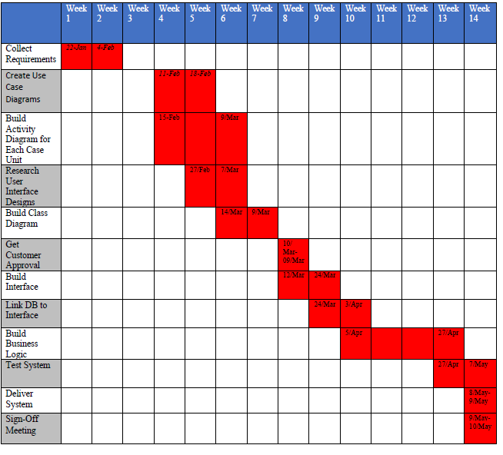

Sources:

SNHU [CS 255 DriverPass Interview Transcript.pdf (snhu.edu)](https://learn.snhu.edu/content/enforced/1196060-CS-255-T2791-OL-TRAD-UG.22EW2/course_documents/CS%20255%20DriverPass%20Interview%20Transcript.pdf?_&d2lSessionVal=98fQUlkkf61ZnT6HG1ROPbsxy&ou=1196060)